|  |  |  |
| --- | --- | --- |
|  |  | INSTITUTO INTERNACIONAL DE IDIOMAS  ENGLISH III – Task 2  *“Describing my process”* |

**Name & Code: CARLOS DAVID ESCAMILLA**

**CODE: 202311162**

**Task links:**

<https://youtu.be/2qpM_C4IG1k>

<https://www.canva.com/design/DAGjoct6D2I/M5yalDk7_XlI1zELH9_xfw/view?utm_content=DAGjoct6D2I&utm_campaign=designshare&utm_medium=link2&utm_source=uniquelinks&utlId=h08fa041a8b>

**Student’s ID CARD (PHOTO):**

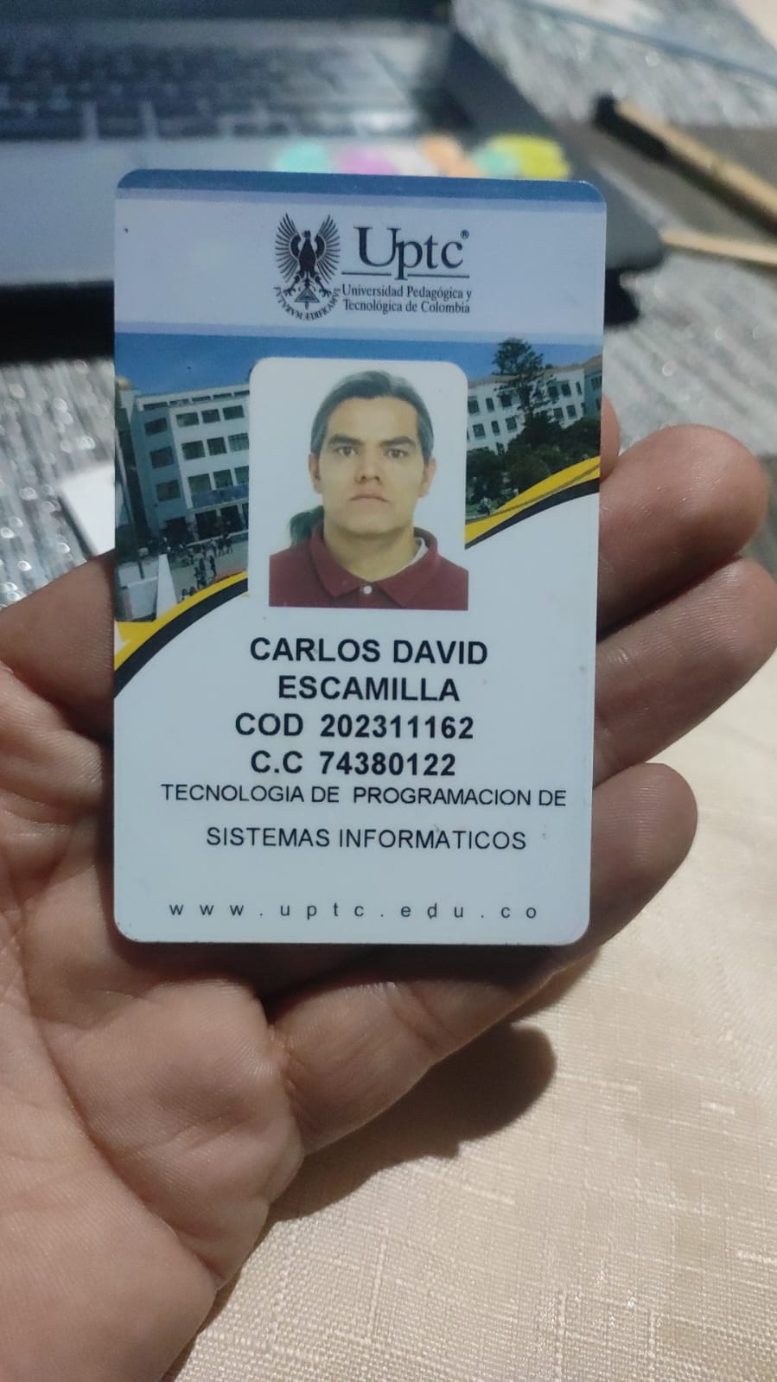

**Context:**

**In 5 years…**

1. Family situation…

* My family will grow, and I might have new members.
* We will not live in the same house anymore.
* We are going to spend more time together on vacations.
* My siblings are not going to live in the same city as me.

1. My professional goals…

* I will have a higher position in my company.
* I will not stop learning new skills.
* I am going to start my own business.
* I am going to work in a job that make me happy.

1. A trip I want to make…

* I will visit at least one country I have never been to.
* I will not travel alone this time.
* I am going to explore new cultures and try new foods.
* I am not going to stay in luxury hotels, I prefer unique experiences.

**In 10 years…**

1. My couple and I…

* We will have a strong and happy relationship.
* We will not argue about small things anymore.
* We are going to travel to many beautiful places together.
* We are not going to forget to support each other in difficult times.

1. The possessions I want to have…

* I will buy my dream house.
* I will not waste money on things I don’t need.
* I am going to have an electric car.
* I am not going to collect useless stuff in my home.

1. The dreams I want to accomplish…

* I will achieve financial freedom.
* I will not give up on my biggest goals.
* I am going to write a book about my experiences.
* I am not going to let fear stop me from trying new things.